Sunday 21st November
Today is the feast of Christ the King. Jesus didn’t live in a palace or wear a gold crown, so what kind of king is he? Let’s find out today.
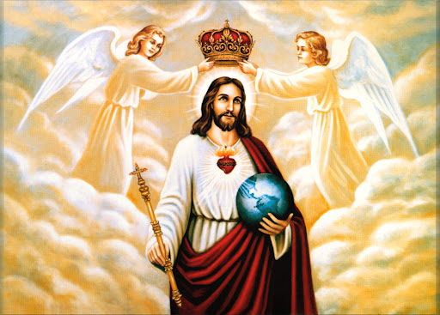
Gospel: John 18:33-37
Pilate went back into the palace and called Jesus. “Are you the King of the Jews?” he asked him.
Jesus answered, “Does this question come from you or have others told you about me?”
Pilate replied, “Do you think I am a Jew? It was your own people and the chief priests who handed you over to me. What have you done?”
Jesus said, “My kingdom does not belong to this world; if my kingdom belonged to this world, my followers would fight to keep me from being handed over to the Jewish authorities. No, my kingdom does not belong here!”
So Pilate asked him, “Are you a king, then?”
Jesus answered, “You say that I am a king. I was born and came into the world for this one purpose, to speak about the truth. Whoever belongs to the truth listens to me.”

Jesus’ kingdom isn’t on earth. We can’t see it. Jesus doesn’t wear a crown or have lots of riches. He doesn’t live in a palace with lots of servants. Jesus was born in a stable and mostly lived a normal life in a carpenter’s family.

We cannot see his kingdom and he doesn’t behave like a normal king. And yet, Jesus is a very special king, because he is the Son of God.

Jesus shows us that you do not have to be rich or powerful to be important. He shows us that what is more important is how you treat others. What we do and say is much more important than whether we are rich or poor, or where we come from.

He shows us how to welcome strangers and to be kind to people that others don’t like. He shows us how to stand up for what is right and to love one another.

Pilate is confused. He couldn’t understand what Jesus was saying. So he asks Jesus again if he is a king. Jesus replies that he was born to come into the world and share the truth with all people.

He came to share the truth of God’s love for all people with us. He came to show us how to live, to teach us to help others, to love our neighbours and to share with them. And to pay more attention to what people do and say, than where they come from or what they look like.

(Taken from the CAFOD children’s liturgy)

