Sunday 14th November

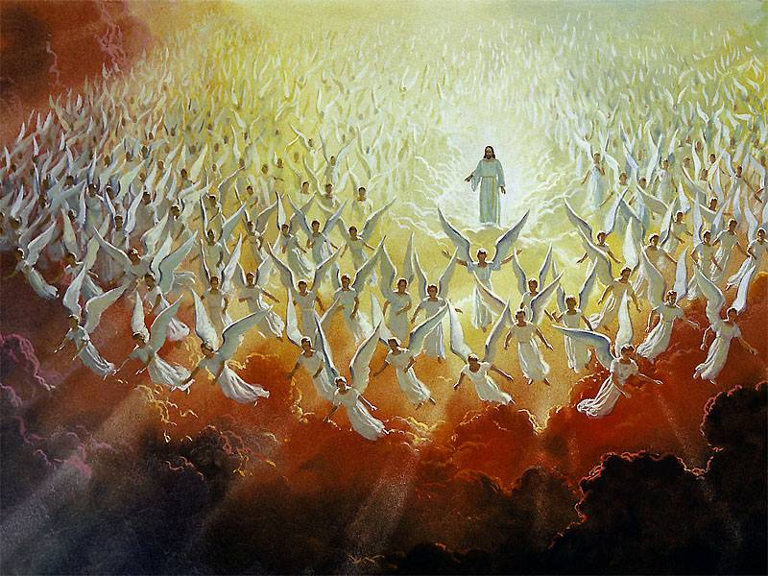
Gospel: Mark 13:24-32
“In the days after that time of trouble the sun will grow dark, the moon will no longer shine, the stars will fall from heaven, and the powers in space will be driven from their courses. Then the Son of Man will appear, coming in the clouds with great power and glory. He will send the angels out to the four corners of the earth to gather God's chosen people from one end of the world to the other.
“Let the fig tree teach you a lesson. When its branches become green and tender and it starts putting out leaves, you know that summer is near. In the same way, when you see these things happening, you will know that the time is near, ready to begin. Remember that all these things will happen before the people now living have all died. Heaven and earth will pass away, but my words will never pass away.
“No one knows, however, when that day or hour will come—neither the angels in heaven, nor the Son; only the Father knows.”

