Pupil premium strategy statement (primary)

- Summary information
School | St Joseph’s Catholic Voluntary Academy, Leicester
Academic Year | 21/22 | Total PP budget | £58,093 | Date of most recent PP Review | Pentecost 2021
Total number of pupils | 246 | Number of pupils eligible for PP | 51  20% | Date for next internal review of this strategy | Lent 2021

- Current attainment
 | Pupils eligible for PP end of Academic Year 2021 |  |  | Pupils not eligible for PP (national average)
% achieving in reading, writing and maths  (Numbers in brackets represents number of PP cohort achieving ARE) | Reading 47%  (20/43 | Writing 33%  (14/43) | Maths 44%  (19/43) | R = 87%  W = 87%  M = 88%  Combined = 83%
% making progress in reading | 44% (16) |  |  | Exp = 84%  GP = 36%
% making progress in writing | 22% (8) |  |  | Exp = 79%  GP = 22%
% making progress in maths | 51% (19) |  |  | Exp = 83%  GP = 27%

- Barriers to future attainment (for pupils eligible for PP, including high ability)
In-school barriers (issues to be addressed in school, such as poor oral language skills)
 |  | Poor attainment and progress in the key core areas of reading, writing and maths.
 |  | Inconsistent attendance and punctuality for all pupils overall attendance for Pupil Premium cohort was 83%.
C. |  | Lack of self-esteem, resilience and vision restraining children from fully reaching their potential as learner of today and citizens of tomorrow.  Ensure that children are well supported in their social, emotional and behavioural needs.
External barriers
D. |  | Poor parental involvement and engagement with the curriculum and all aspects of school life.
- Desired outcomes
 | Desired outcomes and how they will be measured |  | Success criteria
 | Pupils to make at least expected progress and at least comparable to non-Pupil cohort.  Pupils leave EYFS achieving Early Learning Goals.  All children leave KS1 as confident readers with the ability to decode texts.  Children to leave KS2 as well rounded readers able to apply their skills to a wide range of academic and real life contexts. |  | Attainment and progress data will show levels of progress at least comparable to non- Pupil cohort.  Pupils will demonstrate positive and improving attitudes to learning.  Pupil Premium children to access all areas of the school’s broad and balanced curriculum. Where there are barriers to learning, there are mechanisms in place to overcome these.  All children to leave EYFS having reached their Early Learning Goals.  100% of Pupil Premium children to pass phonics screening.  Children leave KS2 as confident, capable readers with their attainment in line with non-Pupil Premium cohort.
 | Children to be present at school consistently – Attendance to be above 95% per child.  Children will attend school punctually.  Children and families of pupil premium children will be well supported during any further lock down measures. |  | Children will arrive at school on time.  All children will have consistently high attendance and punctuality.  High levels of interaction between school and the families of pupil premium children during future lock down periods.  During any further periods of lock down, pupil premium children will be well supported in school, at home and during their return to school.
 | Improve emotional well-being and understanding so that children are resilient, confident and adaptable to face the challenges of today’s modern society. |  | Pupils respond over whelming to pupil voice questionnaires.  90% of pupils to attend after school clubs and extra-curricular activities.  Behaviour records show Pupil Premium children show positive behaviour in school. Where this is not the case, support is put in place.  ELSA to support Pupil Premium children and their families.
 | Develop parental engagement and home-school relations. |  | All Pupil Premium children have at least one parent attending parent’s evening.  Parents have positive perceptions of school reflected in parent’s surveys and questionnaires.  Parents attend school meetings to discuss incentives, events and curriculum discussions.

- Planned expenditure
Academic year | 2021-2022
The three headings below enable schools to demonstrate how they are using the pupil premium to improve classroom pedagogy, provide targeted support and support whole school strategies.
- Quality of teaching for all
Action | Intended Outcome | What is the evidence and rationale for this choice? | How will you ensure it is implemented well? | Staff lead | When will you review implementation?
Quality First Teaching for all  Teacher knowledge and understanding of the personal targets of Pupil Premium children.  Development of whole school strategies and effective, targeted CPD.  Provide training for all staff to ensure assessments are interpreted and administered correctly.  Improve the quality of social and emotional learning (SEL).  Immediate and continual oral feedback during or immediately after lessons to correct misconceptions.  Use of NFER papers to accurately assess in reading and maths to provide accurate gaps analysis.  Pupil Progress Meetings modelled on EEF tiered approach.  School analysis of internal data Target Track. | Pupil Premium children to make accelerated progress and achieve higher attainment in the core skills areas of reading, writing and maths.  With a high degree of uncertainty as to whether the school year will be interrupted further by Covid-19, the school has ensured it has a robust and high quality remote learning package.  Quality and targeted CPD.  Quality feedback day to day for each child.  Pupils display positive opinions about their work, progress and the school.  Attendance for all pupils above 95% | EEF recognises great teaching as an essential leveller in improving outcomes for pupils.  Ensuring every adult is supported and prepared is essential in achieving the best outcomes for pupils. Each teacher knows their children and their educational targets. Individualised Instruction EEF +4, Parental Engagement EEF +4 Teaching and Learning Tool Kit  It is well documented that verbal feedback during or immediately after lessons is the most effective feedback. Feedback EEF +6 Teaching and Learning Tool Kit  The school recognises that effective assessment is integral to supporting great teaching.  ‘Assessment (to help identify gaps and ascertain what learning has been remembered/forgotten) was identified as the top priority by head teachers to support students when school reopens for all pupils.’ TeacherTrapp | Regular monitoring of teaching and learning (weekly)  Analysis of Target Track Data.  Regular scrutiny of pupil’s work.  Regular Pupil Voice questionnaire and interviews.  Monitoring of online content. | HT  SLT | Termly Reviews and Ongoing
Total budgeted cost |  |  |  |  | £19,025

- Targeted Support
Action | Intended Outcome | What is the evidence and rationale for this choice? | How will you ensure it is implemented well? | Staff lead | When will you review implementation?
Accelerated Reader  £ 1000 | All children to leave as confident, well-rounded readers. | Reading Comprehension Strategies EEF +6 Teaching and Learning Tool Kit | Monitoring by literacy co-ordinator.  Pupil Voice questionnaires.  Pupil Progress meetings and Target Track Progress data. | HT  RA | December 2021
Additional Reading Books
£1000
NESSY  £300 |  | Teaching Assistant Interventions EEF +4 Teaching and Learning Tool Kit | Monitoring by literacy co-ordinator and SENCO.  Pupil Progress meetings and Target Track Progress data. | RA  SOG | December 2021  July 2022
Additional phonics support  £270  Teaching Assistant  £9480 |  | Phonics approaches have strong evidence base indicating a positive impact on pupils, particularly from disadvantaged backgrounds.  Phonics EEF +5 Teaching and Learning Tool Kit | Monitoring by literacy co-ordinator.  Pupil Voice questionnaires.  Pupil Progress meetings and Target Track Progress data. | HT  RA | December 2021
ELSA  £9480 | Children to feel emotionally well supported and able to express and develop their feelings. | Oral language intervention EEF +6 Teaching and Learning Tool Kit  Metacognition and Self-Regulation EEF +7 Teaching and Learning Tool Kit | External supervision ELSA programme.  Monitoring and coordinating with SLT. | HT | December 2021  July 2022
SENCO Support  £ NA | Children with SEND needs supported in all aspects of school life.  All children are supported, able to fully access lessons and challenged. | Social and Emotional Learning EEF +4 Teaching and Learning Tool Kit  Individualised Instruction EEF +4 Teaching and Learning Tool Kit | Scrutiny of provision maps and IEPs by SENCO.  Parental engagement.  Pupil Progress meetings and Target Track Progress data. | SOG | October 2021  March 2022  July 2022
NELI  £300 | Children’s language and early literacy improve in EYFS. | Oral language intervention EEF +6 Teaching and Learning Tool Kit | Regular Monitoring by staff.  Children achieving Early Learning Goals | HT  RA | December 2021  July 2022
Catch Up Tutor  £1800 | To improve progress and attainment of pupils in upper KS2 | Academic Mentoring EEF +2 Teaching and Learning Tool Kit  Small Group Tuition EEF +4 Teaching and Learning Tool Kit | Pupil Progress meetings and Target Track Progress data. | HT | December 2021  July 2022
Total budgeted cost |  |  |  |  | £23,630

- Other approaches
Action | Intended Outcome | What is the evidence and rationale for this choice? | How will you ensure it is implemented well? | Staff lead | When will you review implementation?
Behaviour Watch  £2144 | Children understand how to conduct themselves in society growing into mature and responsible young people, taking ownership of their behaviour and actions. | Metacognition and Self-Regulation EEF +7 Teaching and Learning Tool Kit | Data analysis and scrutiny. | GS | December 2021  March 2022
Extra-Curricular activities provided  £2500 | Children are given a rich variety of opportunities for music, sport and extra-curricular activities.  Pupils to attend school residential excursions. | All children are provided rich life experiences to aid classroom learning and support emotional development. | Priority given to Pupil Premium children.  Monitor levels of attendance of Pupil Premium children at extra-curricular activities to ensure they are consistently high.  Parental engagement.  Pupil voice questionnaire. | GS | December 2021  March 2022
School Uniform and resources  £505 | Children have correct school uniform.  All children adhere to the school’s uniform policy. | Children feel fully included in school life and are not seen to be visibly disadvantaged to their peers. | Ongoing monitoring of school uniform.  Regular family engagement. | HT | December 2021  July 2022
Morning Club  £199 | Children attend morning club improving attendance and punctuality. | Children arrive to school punctually. | Attendance analysis.  Parental engagement. | GS | December 2021  July 2022
Parent Workshops  £NA  Parent Forums  £295.50 | The school communicates well with parents fully engaging them at all levels of school life maintaining positive relationships. | Parental Engagement EEF +4 Teaching and Learning Tool Kit | Parental engagement.  Analysis and scrutiny of parent feedback.  Improving attendance at future meetings. | GS | December 2021  July 2022
Home learning resources  £200 | Children have access to online lessons | Ensure that pupils have full access to the school’s Blended Learning strategy and are able to full participate in home learning. | Parental engagement forums and feedback questionnaires | HT | December 2021  July 2022
EWO  £4,800  Faith In Families  £4,794 | Children feel emotional well supported in school.  Families of vulnerable children feel supported.  Rates of attendance and punctuality improve. | Metacognition and Self-Regulation EEF +7 Teaching and Learning Tool Kit  Ensure that pupils have high levels of attendance. | Regular ongoing DSL meetings.  Parental engagement.  Scrutiny of attendance data. | HT  DSL | December 2021  March 2022  July 2022
Total budgeted cost |  |  |  |  | £15,437.50

- Review of expenditure
Previous Academic Year |  | 2020/21
- Quality of teaching for all
Desired outcome | Chosen action/approach | Estimated impact: Did you meet the success criteria? Include impact on pupils not eligible for PP, if appropriate. | Lessons learned  (and whether you will continue with this approach) | Cost
The gap closing between PP children and others in all year groups for reading, writing and math. Closing gap within school versus non disadvantaged children in all year groups and at the end of Year 6 | Presenting the progress of PP children first at pupil progress reviews and monitoring and moderation activities focusing on PP children | 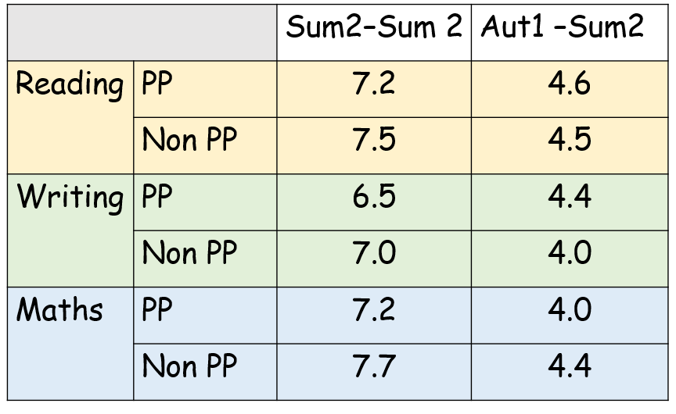 | Pupil premium children closely monitored by all class teachers through the EEF tiered approach.  Teachers fully aware of PP children and individual needs highlighted by this approach.  Pupil premium children received intervention  Children prioritised during Lock Down – Not all children engaged with this.  Children received support at home (Laptops/ phone calls Home delivery, stationary) The school is in a strong position to support families in case of an additional lockdown.  Year 6 children prioritised (SATS Preparation)/ Academic Tutor- Data reflects progress with this group, this approach will be continued with in UKS2 | £ 32,600
All staff able to talk confidently about PP children and their attainment and progress.  All teaching staff to actively build positive relationships with PP parents where possible. | Appraisal targets for teachers and TAs focusing on disadvantaged groups linked to SEF and SIP. | 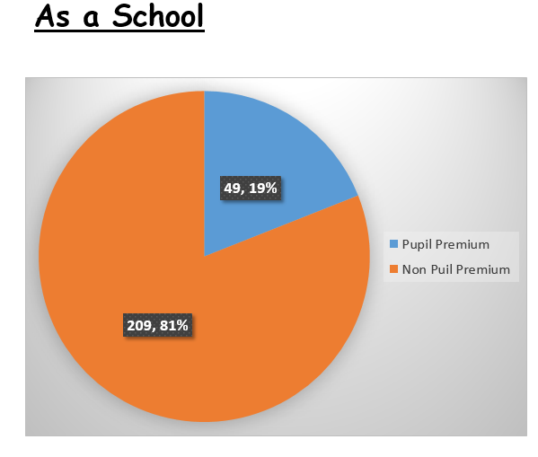  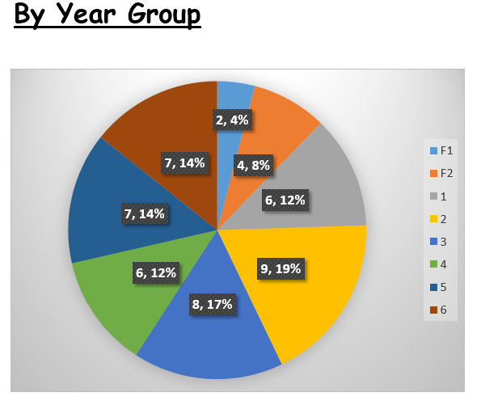 | Teachers have an excellent understanding of their target groups and provide class intervention with use of the EEF, the school will continue with this approach.  The school has appointed an ELSA who will work closely with pupil premium children and their teachers.  Relationships with parents and Carers increased throughout year. Evidence from parent questionnaires and feedback in general shows positively.  The school recognises that this is still an area for development.
To maintain the % of disadvantaged pupils achieving a good level of development at the end of FS2  % of disadvantaged children achieving GLD will be the same as non-disadvantaged children | Discussion at KS meetings  Awareness of the children, their family and individual needs | Reading  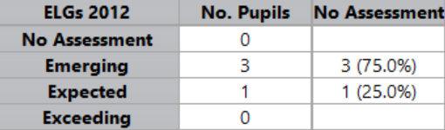  Writing  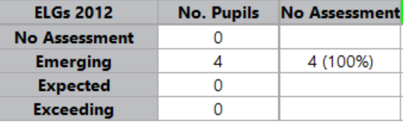  Maths  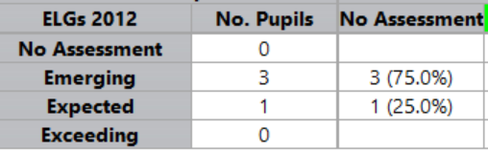 | Poor attendance of disadvantaged children – Throughout year 2020/21, poor Engagement with class teachers.  Attendance and participation of children in EYFS will be monitored this year, along with the children who didn’t make this year.  EYFS staff will give greater focus to pupil premium children through their action plan.
- Targeted support
Desired outcome | Chosen action/approach | Estimated impact: Did you meet the success criteria? Include impact on pupils not eligible for PP, if appropriate. | Lessons learned  (and whether you will continue with this approach) | Cost
Higher than 60% of children at the end of Year 6 meeting the expected standard in reading, writing and maths | Small group support in Year 6 for reading and maths lead by teachers. | PP Non-PP  Reading 86% 79%  Writing 86% 72%  Maths 56% 71%  Reading  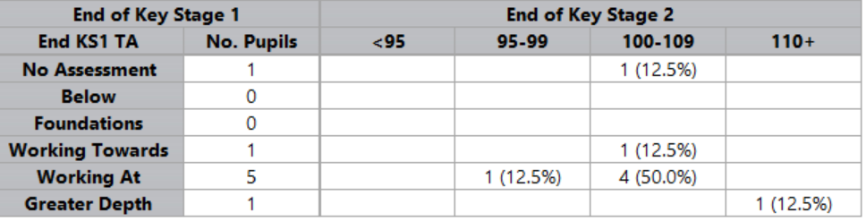  Writing  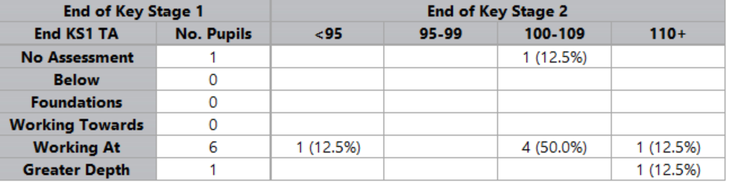  Maths  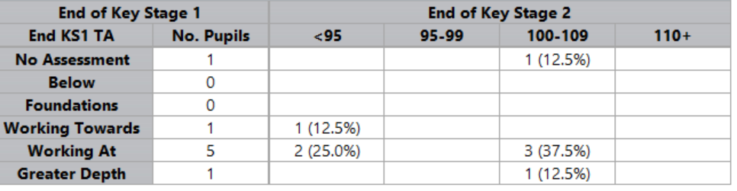 | As a percentage, pupil premium children out performed their non-pp peers in reading and writing.  This was achieved through the provision and delivery of an effective blended learning programme, intervention and a SATS tutor group.  The school will look to ensure that attainment in maths is line with the positive statistics displayed in reading and writing.  From feedback, some of the children found accessing the mastery curriculum that the White Rose scheme of work prescribes a challenge without the support of being in school. | £20,244
Children attaining at least as well as non-PP children | Prioritizing children for intervention who are PP (whatever their ability) and parents told what intervention their child is receiving | Year 6 Non PP Attainment  Reading  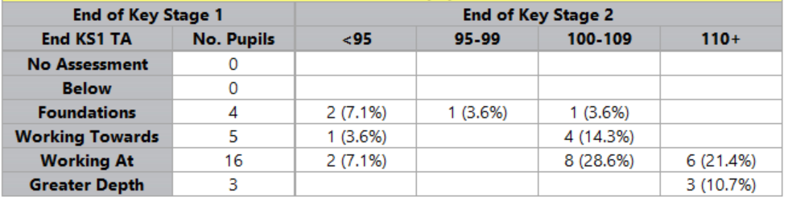  Writing  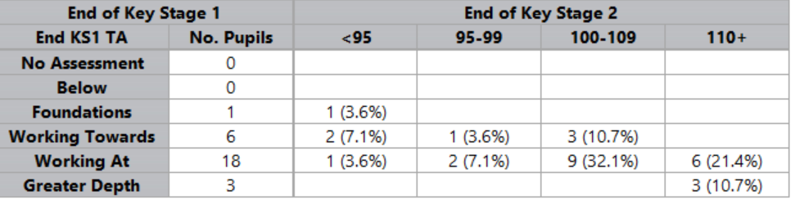  Maths  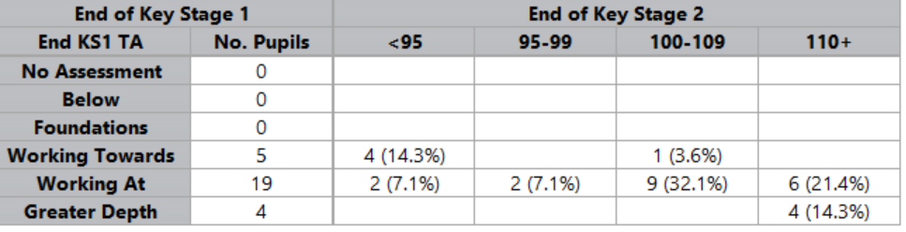 | During the lockdown period of the 2020-21 academic year the school was in regular contact with home learners and their families.  Daily online lessons were provided to accurately reflect the content and challenge the children would have faced in school.
- Other approaches
Desired outcome | Chosen action/approach | Estimated impact: Did you meet the success criteria? Include impact on pupils not eligible for PP, if appropriate. | Lessons learned  (and whether you will continue with this approach) | Cost
Attendance of all children to be consistently very good at 95% or above. | Regular monitoring by the HT and Educational Welfare Officer with panel meetings where appropriate. | Overall Attendance  Pupil Premium Non-Pupil Premium  83% 92%  Attendance over lockdown period.  Jan Feb March March+  35% 63% 71% 97% | During the lockdown period the attendance of all pupils was closely monitored.  As a vulnerable group, pupil premium children were encouraged to attend school. Despite this, there have been some instances of pupil’s attendance dropping below 95%.  The school will offer incentives to improve attendance particularly among those children with historical poor attendance.  The school’s ELSA will now liaise closely with pupils premium children and their families, along with the EWO and Faith In Families to improve attendance. | £5994
Increase parental engagement and attendance at all information workshops and home learning events so that all Pupil Premium children have access to increased and sustained support. | An audit and survey to gather the information then action based on the findings |  | Due to the implications of COVID restrictions the school was restricted in terms of the quantity and variety of parent workshops the school would usually run.
Children are well supported in their social, emotional and behavioural needs. | Build on this year’s St Joseph’s Pride initiative for children in KS2.  Ensure funding for all PP children have full school uniform and equipment suitable for school.  Ensure all pupils dietary requirements are met daily and they develop an understanding of healthy eating.  Enrichment activities (trips, theatre visits) provided free of charge. |  | There is still a need to raise self-esteem and self-worth amongst the pupil premium pupils, along with raising their profile around the school.  All children who contacted the school were supplied with school uniform, stationary and technological equipment to support their learning.  Due to lockdown, the school was unable to offer any excursions but will look to do so immediately in the new year.

- Additional detail
In this section you can annex or refer to additional information which you have used to inform the statement above.
Our full strategy document can be found online at: www.aschool.sch.uk

