‘CHALLENGE CHASERS’

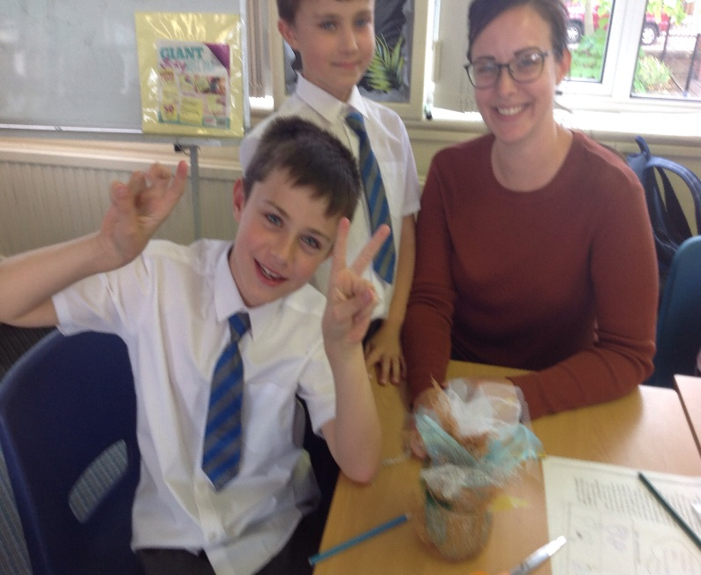

‘Our School values and supports the important role that families play in the life of a child. Where parents are more involved children do better and achieve more’

G.Skye & H.Beall

Challenge Chasers Launch Evening Parent Feed Back – September 12th 2018

TASK 1 - We learnt more about Roald Dahl, his books and his characters. We highlighted words, phrases and sentences from a passage of the BFG and used them to create a scene from the story.

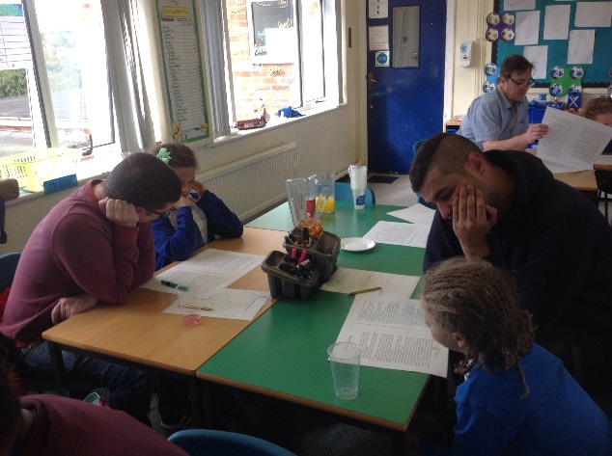
‘We got to spend some time with MJ doing something where we have to work together as a team.’
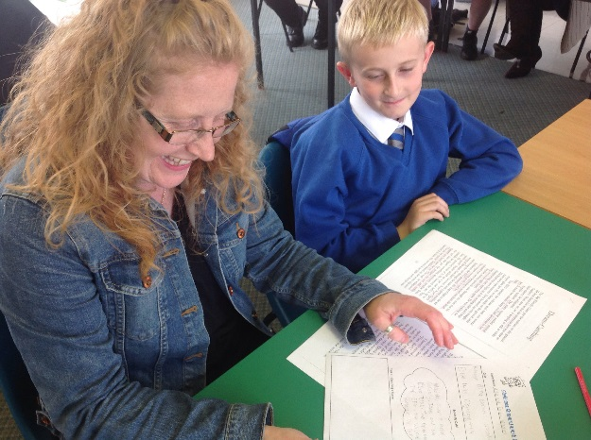
‘It was great seeing L in the classroom environment.’

’An excellent opportunity to engage with children and teachers’.

Task 2 - We wrote our own dreams using our imaginations and created a dream capsule to keep it in.

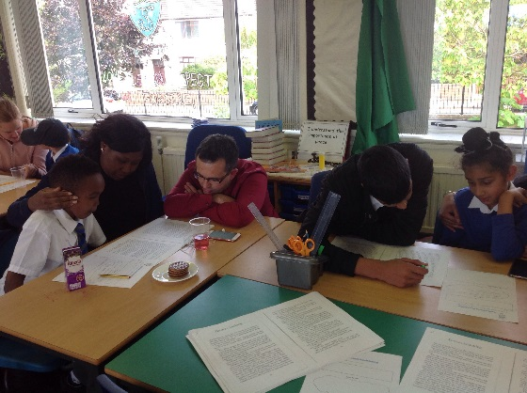
‘Making the dream capsule was a lot of fun.’

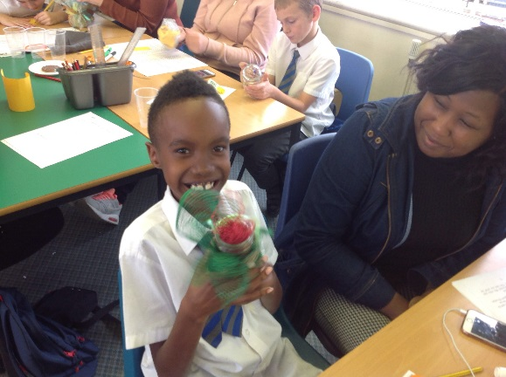
‘I can’t write but give me something to do with my hands and I can do it’.

‘We all worked together and got to meet new people.’
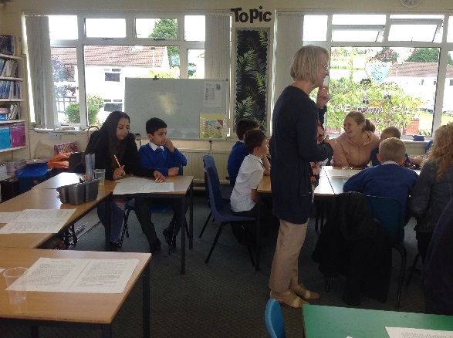
‘I enjoyed it because it’s very creative and we can use our imagination a lot’.
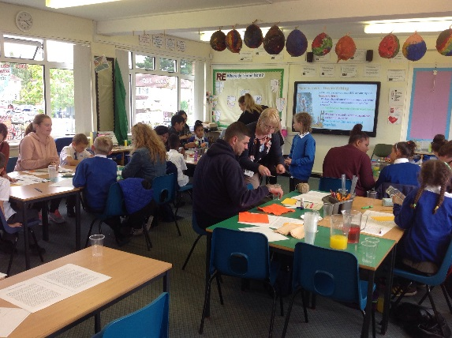
‘Yes I have never been to any programme before. I enjoyed doing the activities and crafts.’
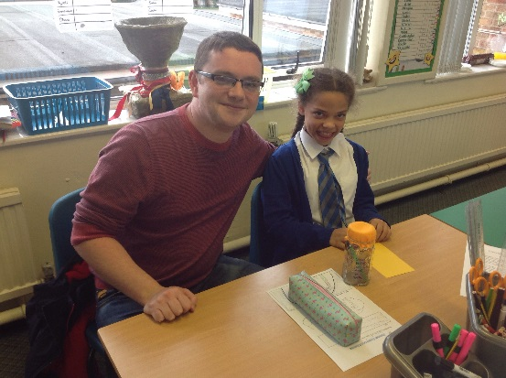
‘Seeing how much R has progressed and can use his imagination.’
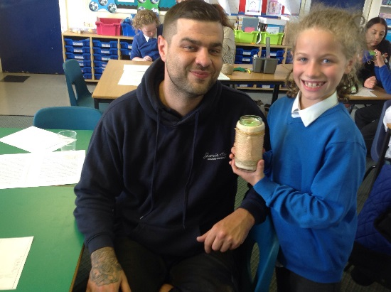
‘It was lovely for C to mix and spend time with me, as we always do.’
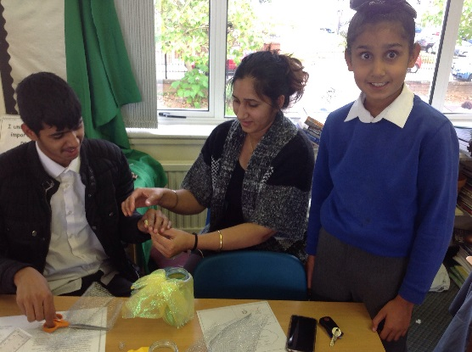

CEREMONY - We celebrated our achievements as a team.

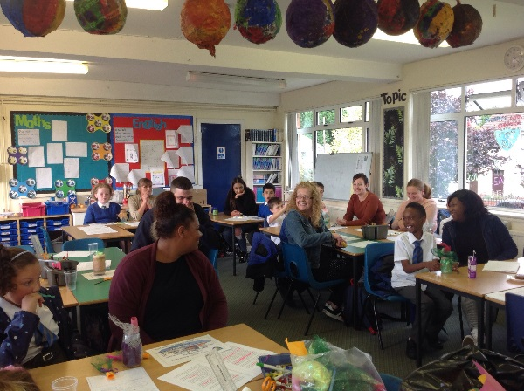
‘My child has made friends and he has also not been shy like he normally is.’
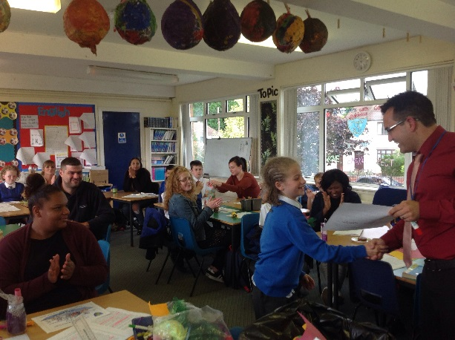
‘I think A has benefitted from spending time doing something fun together with me in school.’

All Parental Feedback

Did you enjoy coming to our Roald Dahl evening. If so why?
Yes we got to spend some time with MJ doing something where we have to work together as a team.
Yes excellent opportunity to engage with children and teachers.
Yes it was great seeing L in the classroom environment.
Yes I have never been to any programme before. I enjoyed doing the activities and crafts.
Was good to see what T is learning about. As T is new to the school also chance to meet teachers and get to know the school more.
Yes it was lovely spending time with everyone and making things, learning more information.
Yes we all worked together and got to meet new people.
Yes it was a great opportunity to spend time working together on something.
I enjoyed it because it’s very creative and we can use our imagination a lot.
Yes.

What did you enjoy the most?
Creating the dream capsule.
Team work, craft building.
Making the dream capsule.
Seeing how much R has progressed and can use his imagination.
Creative glass jars.
Making the dream capsule.
Making the dream capsule.
Making the dream capsule was a lot of fun.
Making the dream capsule and drawing.
Making the dream jars.

How do you think your child benefitted from these sessions?
Improving on his Roald Dahl knowledge.
Really well gives time out of class working as a team and having fun in a classroom setting.
Yes at home Luke sister always to help.
I can see R really enjoys challenge chasers and think it has made him more independent.
Learnt more about Roald Dahl books.
It was lovely for C to mix and spend time with me, as we always do.
My child has made friends and he has also not been shy like he normally is.
NA
I think A has benefitted from spending time doing something fun together with me in school.
Yes.

How do you think we could improve the programme further?
I liked what I saw/did so for me at the minute nothing needs changing.
NA
Parent preparation for exams.
Do more parent’s sessions.
NA
Great just as it is, more sessions throughout the year.
Give the children more time to make things so we can see what they like and do not.
NA
NA
No it was perfect.

How would you rate the evening? Please circle.

Excellent 10 | 9 | 8 | 7 | 6 | 5 | 4 | 3 | 2 | Poor  1
6 | 3 | 2

Would you consider attending another session with your child at school?

Yes | No
11

