PP Parent’s Craft Evening

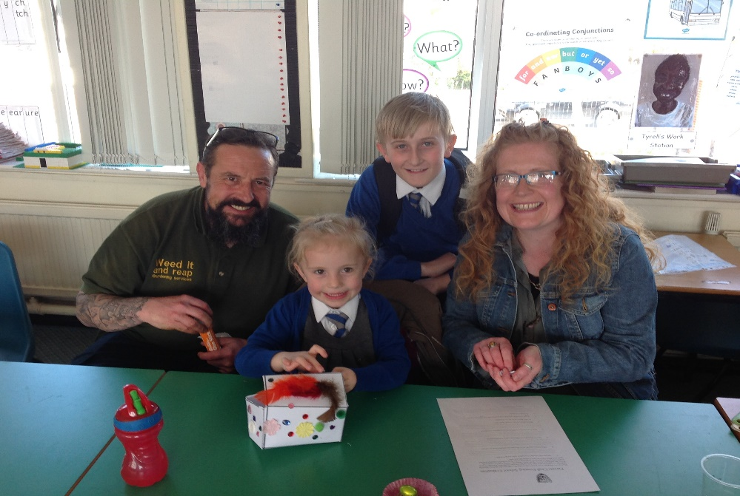

‘Our School values and supports the important role that families play in the life of a child. Where parents are more involved children do better and achieve more’

G.Skye & H.Beall

TASK 1 - We learnt more about the reading dogs, their names, what they represent and how they are used to improve reading.
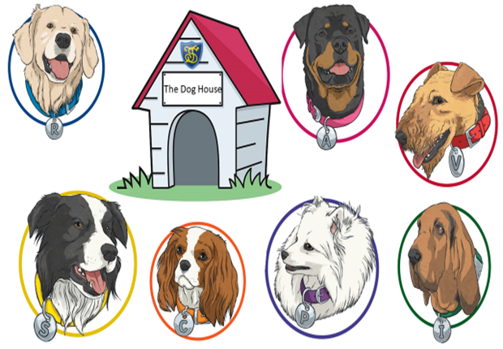

‘It was great fun and good to learn more about the reading dogs’.
‘My daughter has enjoyed herself and it was something new’.
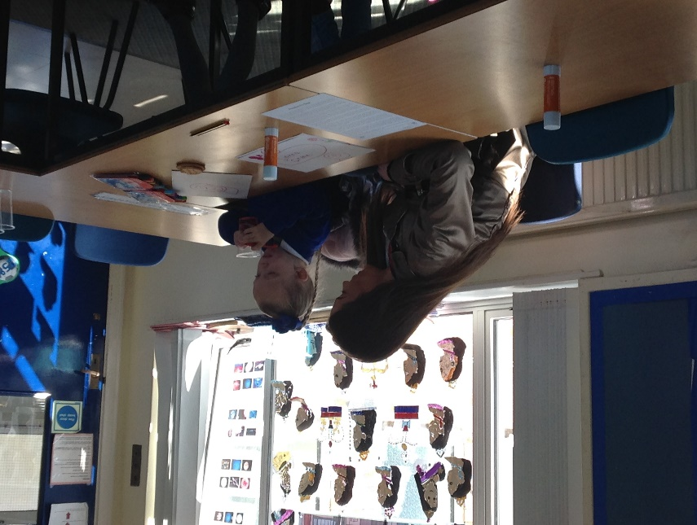

Task 2 - We read Pandora’s Box and answered questions taken from one of our classes’ guided reading sessions.
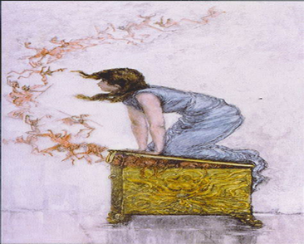
‘By interacting with everyone that came and because it was fun it didn’t seem like work. My daughter actually wanted to come!’

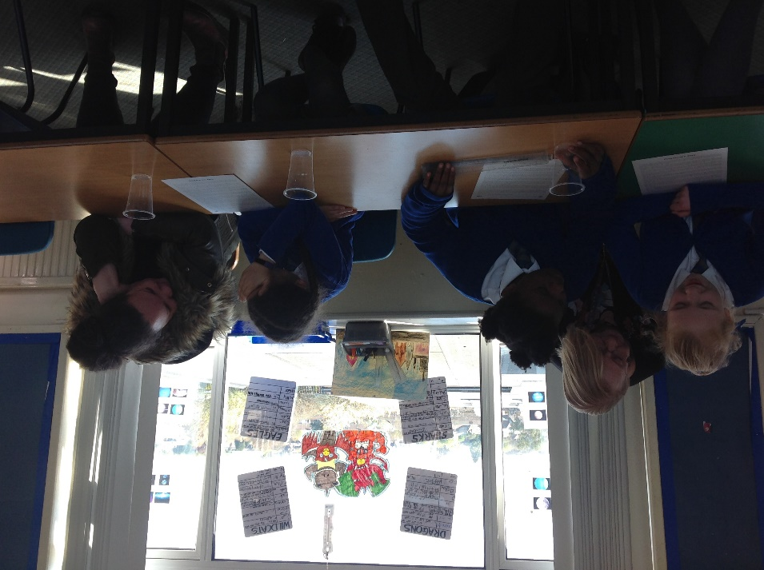

Task 2 – We made our very own Pandora’s Box based on what we read in the text.
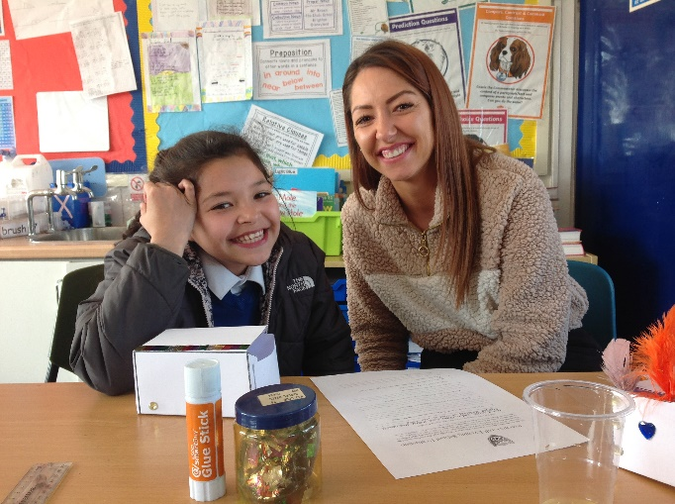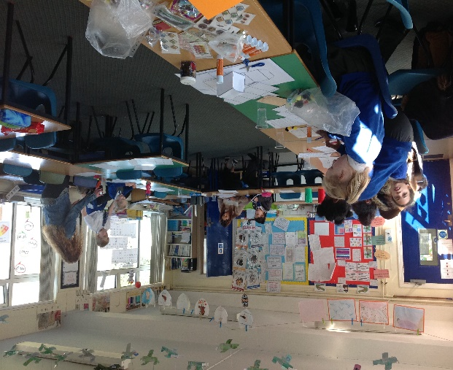
‘We both enjoyed the craft side of things and enjoyed making Pandora’s Box together’.
‘I enjoyed making he crafts with my friends and the food!’
It was great to spend some time doing some art and craft together’.

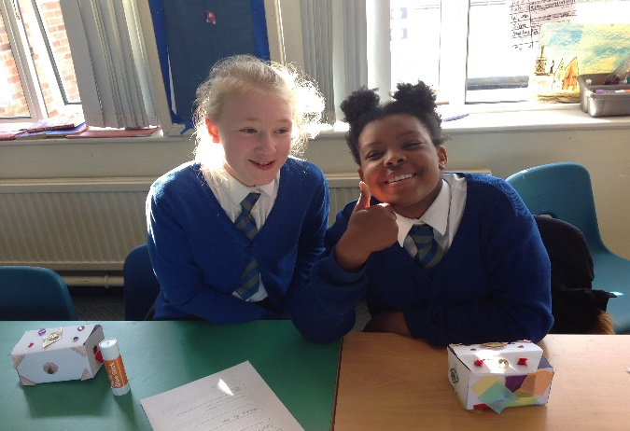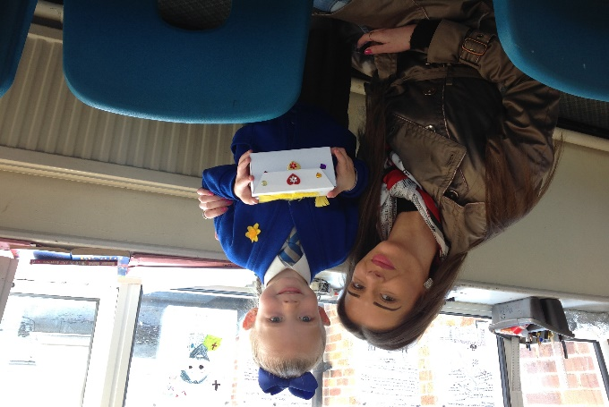

‘I really enjoyed the box making and really appreciate you both giving up your time for the activity. Thank you!’

