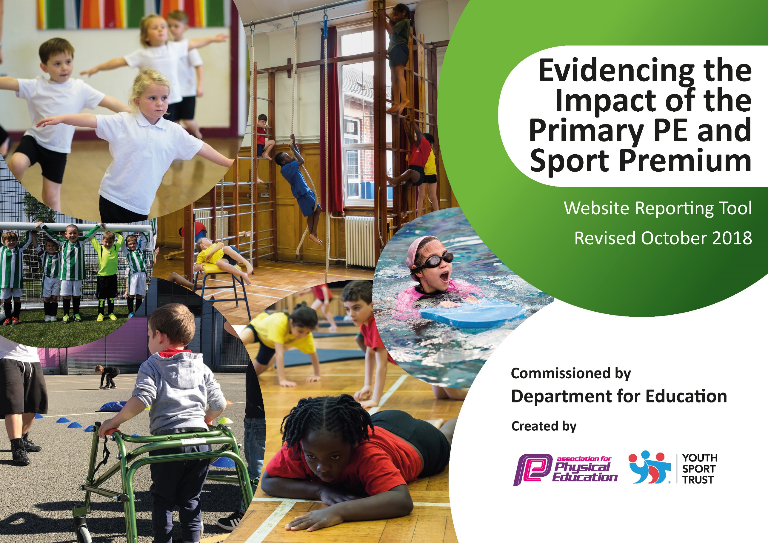
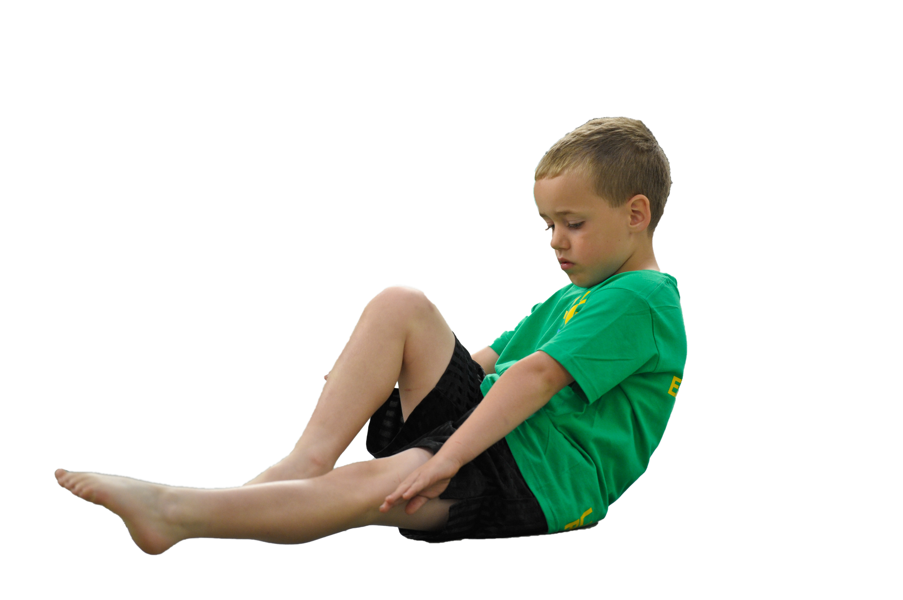
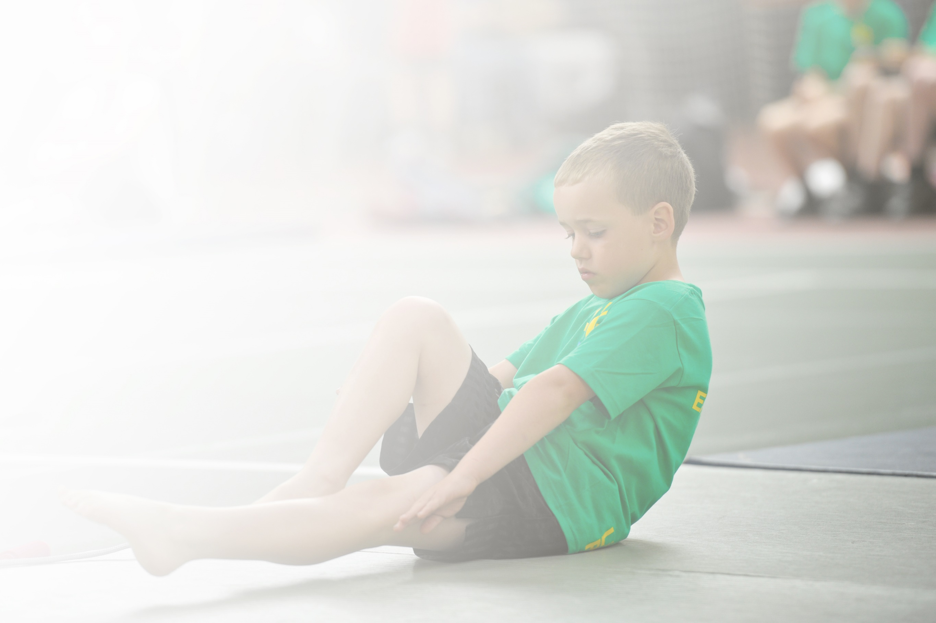
Schools must use the funding to make additional and sustainable improvements to the quality of Physical Education, Sport and Physical Activity (PESPA) they offer. This means that you should use the Primary PE and Sport Premium to:

- Develop or add to the PESPA activities that your school already offer
- Build capacity and capability within the school to ensure that improvements made now will benefit pupils joining the school in future years

Please visit gov.uk for the revised DfE guidance including the 5 key indicators across which schools should demonstrate an improvement. This document will help you to review your provision and to report
your spend. DfE encourages schools to use this template as an effective way of meeting the reporting requirements of the Primary PE and Sport Premium.

We recommend you start by reflecting on the impact of current provision and reviewing the previous
spend. Under the Ofsted Schools Inspection Framework, inspectors will assess how effectively leaders use the Primary PE and Sport Premium and measure its impact on outcomes for pupils, and how effectively governors hold them to account for this.

Schools are required to publish details of how they spend this funding as well as on the impact it has on pupils’ PE and sport participation and attainment by the end of the summer term or by 31 July 2019 at the
latest.
We recommend regularly updating the table and publishing it
on your website throughout the year, as evidence of your
ongoing review into how you are using the money to
secure maximum, sustainable impact. To see an
example of how to complete the table please
click HERE.

Support for review and reflection - considering the 5 key indicators from DfE, what development needs are a priority for your setting and your students now and why? Use the space below to reflect on previous spend, identify current need and priorities for the future.

Key achievements to date: | Areas for further improvement and baseline evidence of need:
New PE scheme of work has been introduced which allows for progression from one year group to the next and includes some resources. Further resources have been purchased to allow PE lessons to be delivered effectively.  Given all children in KS1 and KS2 the opportunity to take part in sports festivals. | Ensure 100% of our Year 6 children are capable of swimming 25m confidently with different strokes and able to perform safe self-rescue. Target group will be identified for extra lessons.  Target less active children by introducing a daily 5-10 minutes physical activity time for all children.  Raise the profile of competitive sports and after school clubs to encourage more children to take part by continuing to recognise achievements in assemblies and have a designated Sports/physical activity notice board with information about upcoming events, results and photos.  Give children the opportunity to work with professional sportsmen/women to inspire them to take part in physical activity.

Meeting national curriculum requirements for swimming and water safety | Please complete all of the below:
What percentage of your current Year 6 cohort swim competently, confidently and proficiently over a distance of at least 25 metres?  N.B. Even though your children may swim in another year please report on their attainment on leaving  primary school. | 57%
What percentage of your current Year 6 cohort use a range of strokes effectively [for example, front crawl, backstroke and breaststroke]? | 57%
What percentage of your current Year 6 cohort perform safe self-rescue in different water-based situations? | 57%
Schools can choose to use the Primary PE and Sport Premium to provide additional provision for swimming but this must be for activity over and above the national curriculum requirements. Have you used it in this way? | Yes

Action Plan and Budget Tracking
Capture your intended annual spend against the 5 key indicators. Clarify the success criteria and evidence of impact that you intend to measure to evaluate for students today and for the future.

Academic Year: 2018/19 | Total fund allocated: £ | Date Updated:
Key indicator 1: The engagement of all pupils in regular physical activity – Chief Medical Officer guidelines recommend that primary school children undertake at least 30 minutes of physical activity a day in school |  |  |  | Percentage of total allocation:
 |  |  |  | %
School focus with clarity on intended impact on pupils: | Actions to achieve: | Funding allocated: | Evidence and impact: | Sustainability and suggested next steps:
Aim to engage all pupils in physical activity – ensuring activities are suitable for all abilities and that the children are accessing the PE curriculum relevant for their age. To ensure progression from one year to the next. | KS1 and KS2 – new scheme of work for PE providing some of the necessary resources for Level 3 TA delivering the sessions and is easily accessible.  Further resources purchased to ensure the curriculum can be delivered effectively. | £540  £12000 | Improved planning. Consistency and progression from one year group to the next. | Ongoing – focus now on developing the fundamental skills for physical activity. Next year all class teachers in KS1 and KS2 to work alongside the more experienced sports coach to give them more confidence when delivering different aspects of the PE curriculum. Continue to replenish equipment as necessary.  Introduce daily ‘St Joseph’s Jog’ for 5-10 minutes per day to help all children to increase their stamina when completing physical activity.
Key indicator 2: The profile of PESSPA being raised across the school as a tool for whole school improvement |  |  |  | Percentage of total allocation:
 |  |  |  | 11%
School focus with clarity on intended impact on pupils: | Actions to achieve: | Funding allocated: | Evidence and impact: | Sustainability and suggested next steps:
Raise the awareness of benefits of being healthy by taking part in regular exercise and the rewards it can bring.  To promote and develop sport participation and competition between MAT schools. | Celebrate all achievements and successes in assemblies.  All children in KS1 and KS2 take part in a Sports Festival organised by the secondary academy linked to St Joseph’s.  Ten children in all years from year 2-6 took part in a football festival. Ten children from year 5 took part in a swimming gala. | £2000 | Certificates, medals and trophies given out in assemblies for athletics, cross-country, gymnastics, tag rugby, swimming, sports festivals and football.  All children in KS1 and KS2 attended the sports festival for their year group. | Continue to recognise achievements in assemblies. Have a designated Sports/physical activity notice board with information about upcoming events, results and photos.  Continue to attend the festivals arranged by the secondary academy.

Key indicator 3: Increased confidence, knowledge and skills of all staff in teaching PE and sport |  |  |  | Percentage of total allocation:
 |  |  |  | %
School focus with clarity on intended  impact on pupils: | Actions to achieve: | Funding  allocated: | Evidence and impact: | Sustainability and suggested  next steps:
Key indicator 4: Broader experience of a range of sports and activities offered to all pupils |  |  |  | Percentage of total allocation:
 |  |  |  | %
School focus with clarity on intended  impact on pupils: | Actions to achieve: | Funding  allocated: | Evidence and impact: | Sustainability and suggested  next steps:
To increase the number of children participating in various sports and activities – aim to target less active children and PP children. | Purchase resources to allow sessions to run effectively. | £12000 |  | Continue to develop and build up the participation in various sports for all pupils.  Investigate and develop different sports
Key indicator 5: Increased participation in competitive sport |  |  |  | Percentage of total allocation:
 |  |  |  | %
School focus with clarity on intended  impact on pupils: | Actions to achieve: | Funding  allocated: | Evidence and impact: | Sustainability and suggested  next steps:
Increase the number of children participating in various sports and activities. | Membership of SSPAN  Membership of LCFC  Provide transport to competitions and swimming. | £1320  350  £1500 | Increased number of KS2 children participating in a range of competitive sporting events – football, gymnastics, athletics, sportshall athletics (SEND), cross-country, tag rugby | Continued participation in sporting competitions aiming to achieve success. Enter a wider range of sports competitions next year.  Continue membership to the SSPAN and LCFC  Continue to provide transport to and from events.  Ensure we give the children competing sufficient time to practice before the event using the expertise of existing members of staff.

