End of year expectations – Year 6
Driver Words | In Year Six This Means
AT1  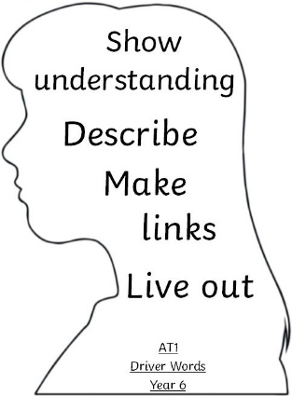 | I can describe and show understanding of some religious sources beliefs, ideas, feelings and experiences, making links between them. (i) Make Links  I can use religious terms to show an understanding of many different liturgies. (ii) Give Reasons  I can show some understanding of how religious belief shapes life in different ways and how Christians live out these beliefs. (iii) Live it out | Both links and reasons can be shaped by some of the following statements;  In the words of Pope Francis…  This links to the words of the Hail Mary because...  In the Bible, we are told…. This can shape our Christian beliefs by ….  As it tells us in Our Father….  The Sacrament of Reconciliation allows us to….
AT2  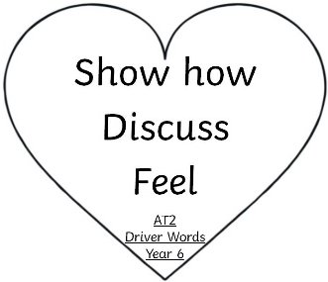 | I can confidently show how my own and others’ decisions are informed by beliefs and values. (i)  I can engage in some discussion about questions of life, in light of religious teaching (ii) | In following the footsteps of Jesus, I can….  By following my Christian beliefs, I can…  Having compared my ideas with Sean Devereux I would also...  Question / Answer / Question.  Discussion and engagement
AT3  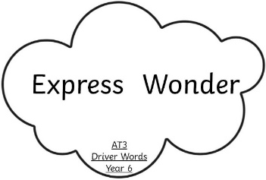 | I can express different points of view (i)  I use sources to support some points of view (ii)  I can arrive at judgements (iii) | This reminds me of… and this is similar to the prayer of….  I prefer... because...  Share viewpoints and some judgements.  Use evidence to support opinion and point of view.

