End of year expectations – Year 5
Driver Words | In Year Five This Means
AT1  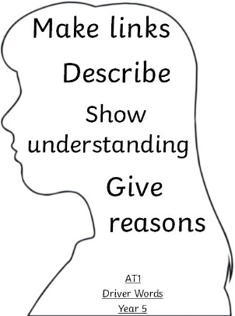 | I can securely make links between most religious stories and people I have shared/ learnt about and beliefs and begin to describe them to show understanding. (i)  Make links  I can use a developing religious vocabulary to give reasons for most religious actions and symbols, within different liturgies. (ii)  Give reasons  I can give religious reasons for most actions by believers and begin to show how they shape believers’ lives. (iii) Live it out | Both links and reasons can be shaped by some of the following statements;  In the words of Pope Francis…  This links to the words of the Hail Mary because...  In the Bible, we are told….  As it tells us in Our Father….  The Sacrament of Reconciliation allows us to….
AT2  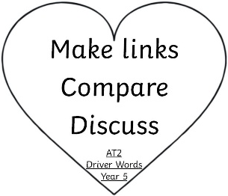 | I can make many links to show how feelings and beliefs affect my behaviour and that of others and begin to show how my own and others’ decisions are informed by beliefs and values. (i)  I am able to compare most of my own and other people’s ideas about questions that are difficult to answer. I can begin to engage in discussion about questions of life, in light of religious teaching. (ii) | In following the footsteps of Jesus, I can….  By following my Christian beliefs, I can…  For example; having compared my ideas with Sean Devereux I would also...  Make different connections between feelings and sources.  Choices / decisions and say why.  Match answers to questions.  Think / Link
AT3  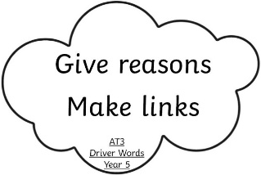 | I can express a point of view and give many reasons for it (i)  I can make a link to many sources that support a point of view (ii)  I can begin to arrive at judgements (iii) | This reminds me of… and this is similar to the prayer of….  Give their point of view, back this up with a source.  Come to an opinion / vote on this?

