End of year expectations – Year 4
Driver Words | In Year Four This Means
AT1  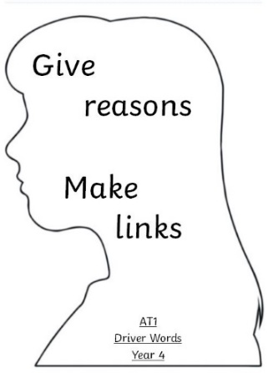 | I can make links between many religious stories and people I have shared/learnt about and beliefs. (i)  Make links  I can use a developing religious vocabulary to give reasons for many religious actions and symbols. (ii)  Give reasons  I can give religious reasons for many actions by believers. (iii)  Live it out | Both links and reasons can be shaped by some of the following statements;  In the words of Pope Francis…  This links to the words of the Hail Mary because...  In the Bible, we are told….  As it tells us in Our Father….  The Sacrament of Reconciliation allows us to….
AT2  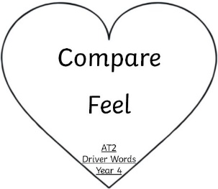 | I can make some links to show how feelings and beliefs affect my behaviour and that of others (i)  I am able to compare most of my own and other people’s ideas about questions that are difficult to answer (ii) | In following the footsteps of Jesus, I can….  By following my Christian beliefs, I can…  Having compared my ideas with Sean Devereux I would also...
AT3  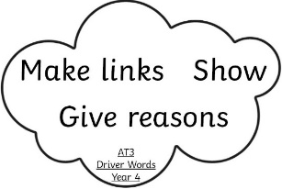 | I can express a point of view and give some reasons for it (i)  I can make a link to some sources that support a point of view (ii)  I can express a preference and give some reason for it (iii) | This reminds me of…  Think of / ask a question.  Use one or more of the ‘5 Ws’. What do you think?  I prefer... because...

