End of year expectations – Year 3
Driver Words | In Year Three This Means
AT1  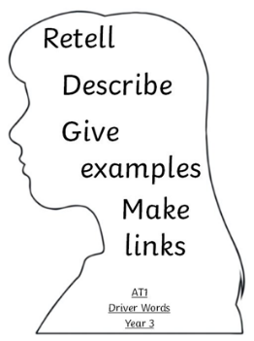 | I can use my own words to accurately retell stories about religious events and people and I have begun to link some of these religious beliefs. (i)  Make links  I can describe most religious signs, symbols and actions using appropriate religious words and phrases and I can give reasons for some of these. (ii)  Give reasons  I can describe and give examples of many ways that people with religious beliefs behave in their everyday lives and give some reasons for their actions. (iii)  Live it out | Some of these begin to shape links and reasons;  In the words of Pope Francis…  This links to the words of the Hail Mary because...  In the Bible, we are told….  As it tells us in Our Father….  The Sacrament of Reconciliation allows us to….
AT2  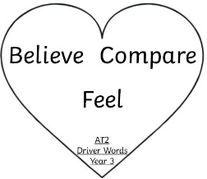 | I can share with and question others about the things that have happened to me and talk about how my and others’ behaviour is influenced by what we feel or believe (i)  I can speak to and question others about things that cause me to wonder, knowing that some questions have no clear answers, and I can also compare some of my own and other people’s ideas about such questions. (ii) | In following the footsteps of Jesus, I can….  By following my Christian beliefs, I can…  Having compared my ideas with Sean Devereux I would also...  Share an experience – express how you feel.  Why did you / they say or do that?
AT3  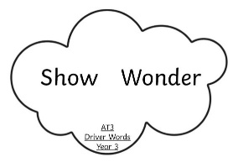 | I can express a point of view and begin to give reason for it (i)  I can make a link to source that supports a point of view (ii)  I can begin to express a preference (iii) | This reminds me of…  I prefer... because...  Think of / ask a question.  Use one or more of the ‘5 Ws’. What do you think?  Reminds me of ……  I prefer…….

