End of year expectations – Year 2
Driver Words | In Year Two This Means
AT1  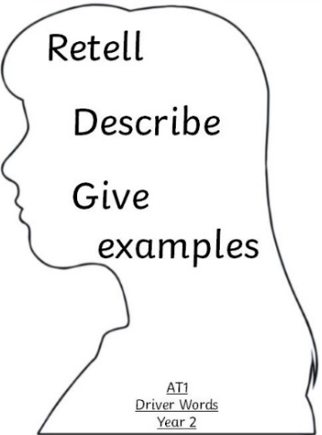 | I am able to retell accurately many key elements from stories within the Old and New Testament using my own words about special people, places and events. (i)  Make links  I can describe many religious signs, symbols and actions used in prayer and Liturgy using appropriate religious words and phrases. (ii)  Give Reasons  I am able to describe and give many examples of ways that people with religious beliefs live their lives because of their religious belief. (iii)  Live it out | Ability to sequence and retell Bible stories with accuracy, and in their own words.  e.g. During Baptism – anointing with oil, white shawl, candle  e.g. daily prayers, try to live like Jesus, make the right choice, going to a place of worship, singing hymns, supporting charities
AT2  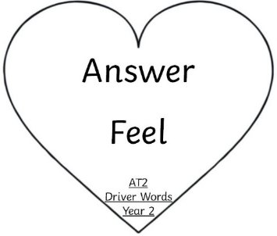 | I am able to ask and answer some questions about how certain experiences make myself and others feel and say why I feel that way. (i)  I can ask somebody why they are wondering about something. I can also say what I wonder about God and Jesus. (ii) | To say what I think and feel. Share this with others.  Opportunities to reflect on a prayer, hymn, picture etc.  What does it ‘say to me’?
AT3  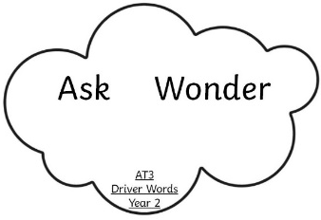 | I can listen and respond to a point of view (i)  I can ask and respond to questions about sources (prayers, hymns and scripture sources) (ii) | This reminds me of…  I prefer... because...  What does this / it make you wonder about?  Compare and share.

