End of year expectations – Year 1
Driver Words | In Year One This Means
AT1  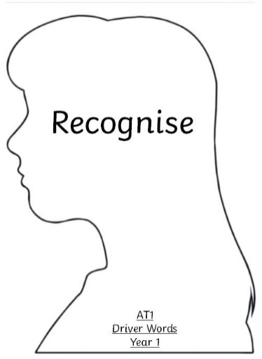 | I am able to recognise some key elements of religious stories and the people in them. (i)  Make links  I am beginning to recognise many religious signs and symbols and use some religious words and phrases. (ii)  Give reasons  I am able to recognise that people act in a certain way because of their religion. (iii) Live it out | The bible tells us about …. name the people and some religious stories  We make the sign of the cross when ….  Some symbols of Baptism are…….  Some Liturgical symbols are…  Explore why we / others are kind, helpful, caring etc.
AT2  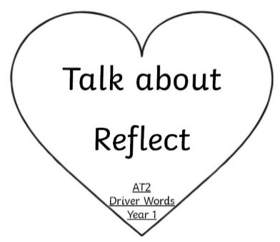 | I can talk about many of the things I have done and how these made me feel. (i)  I can also reflect upon some things I wonder about and talk about these. (ii) | I think and feel this because  I wonder about……
AT3  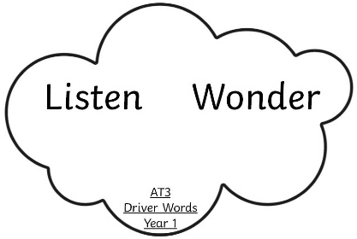 | I can listen to a point of view (i)  I can wonder and talk about some prayers and hymns (ii) | I can listen to what someone thinks  The word(s) in this prayer (or hymn) make me think about….

