Teacher: Mr Challoner Topic: The Great Plague
Text: The Pied Piper of Hamelin Genre: Fairy-tale writing
Intent | Implementation |  | Impact
Learning Objective | Teaching | Activity | Learning Outcomes
LO: I can ask and think of possible answers about character, settings and events. | Watch this adaptation of the Pied Piper of Hamlin up to 1 minute and 45 seconds. | In your book, make a mind map with the titles  Who?  What?  When?  Where?  How?  Why?  Think of answers to all these questions in response to the clip you have watched. There is no right or wrong answer- use your imagination. | Children will be able to raise and answer  questions.  Children will be able to identify the characters,  setting and events.
LO: I can read new words and use a dictionary to find its meaning. | Read this version of The Pied Piper of Hamlin. | Pick 10 challenging words from the text. List them in alphabetical order and use a dictionary to record their meaning.  Use a dictionary at home or use an online version. | Children will be able to identify and clarify new  vocabulary.  Children will be able to use dictionaries and  thesauruses to aid understanding and build a  store of words.
LO: I can compare a written and film version of a story. | Watch this adaptation of the Pied Piper of Hamlin (we watched the opening of this version on Tuesday) and reread the version we looked at yesterday here. | Complete the table from the document list below entitled ‘Thursday English’ to compare the film with the story. | Children will be able to discuss a point and  back up their thinking with evidence from a  text.
LO: I can predict events and character behaviour. | Warm up- watch this video and pause to make predictions. | Be a fortune teller!  Pick a character from the story (either the written or video version) and write a prediction- what do you think will happen to them either during or after the story?  Record your written prediction in your book. You can add illustrations. | Children will be able to predict events and  character behaviour.
LO: Using the plot ideas of the Pied Piper, plan your own fairy tale… | 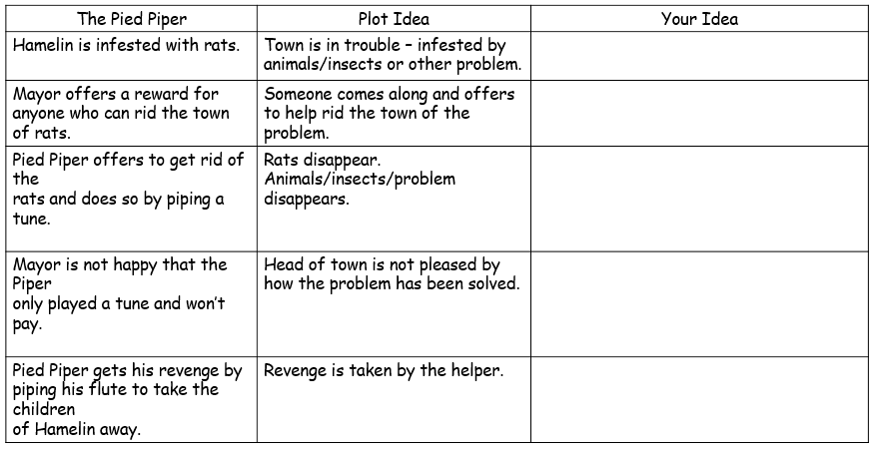 |  | Children will be able to identify key events in a  fairy tale and create a plot pattern.
LO: Write the opening to your Pied Piper story. | The opening of you story should include sentences that do the following:  - Begin with a verb.  - Use 3 or more adjectives.  - Use a sound word- onomatopoeia (eg plop!)  - Begin with an adverb. | Time for writing with checklist of ingredients. | Children will be able to write a story, based on  a model, which includes:  - appropriate use of fronted adverbials for  ‘where’  - speech using inverted commas and other  punctuation  - features of the fairy tale genre.
LO: Write the build up to your Pied Piper story. | The build-up of you story should include sentences that do the following:  - Begin a sentence with ‘Whilst…’  - Use an expanded noun phrase.  - Use a question mark…?  - Use the word ‘during’ | Remember: stick to the main plot ideas of the original fairy tale.  Time for writing with checklist of ingredients. | Children will be able to write a story, based on  a model, which includes:  - appropriate use of fronted adverbials for  ‘where’  - speech using inverted commas and other  punctuation  - features of the fairy tale genre.
LO: Write the problem to your Pied Piper story. | The problem of you story should include sentences that do the following:  - Use a relative clause.  - Start a sentence with ‘In the blink of an eye…’  - A sentence that is 3 words long (for tension)  - Use a metaphor or a simile. | Remember: stick to the main plot ideas of the original fairy tale.  Time for writing with checklist of ingredients. | Children will be able to write a story, based on  a model, which includes:  - appropriate use of fronted adverbials for  ‘where’  - speech using inverted commas and other  punctuation  - features of the fairy tale genre.
LO: Write the resolution and solution to your Pied Piper story. | The resolution and solution to you story should include sentences that do the following:  - Use an ellipses …  - Start a sentence with a feeling word followed by a comma ,  - Use a modal verb | Remember: stick to the main plot ideas of the original fairy tale.  Time for writing with checklist of ingredients. | Children will be able to write a story, based on  a model, which includes:  - appropriate use of fronted adverbials for  ‘where’  - speech using inverted commas and other  punctuation  - features of the fairy tale genre.
LO: Edit and improve your writing. | Read through your writing with a partner. | Check you writing checklist to ensure you’ve covered all areas. | Children will be able to edit their writing.

Teacher: Phil Challoner Topic: Plague
Text: Pied Piper of Hamelin by Robert Browning Genre: Classic Narrative Poetry
Intent | Implementation |  | Impact
Learning Objective | Teaching | Activity | Learning Outcomes
LO: I can identify nouns in a poem. | Read the first two verses of this poem.  Make a list of all the nouns you can find in these first two verses.  Listen to the rest of the poem here:  Part 1  Part 2 | Once you have listened to the poem, see if you can answer the Qs in this quiz. | Children will be able to identify nouns within the context of a poem.
LO: I can collect new words and phrases and investigate meanings. | Re-read yesterday’s poem. | Use the dictionary skills you’re developing to put your 10 words in alphabetical order and find their meaning in a dictionary.  Challenge: pick a new word and use it in a sentence. | Children will be able to collect words and  phrases and investigate meanings.
LO: I can justify responses using evidence from the poem. | I have a list of vocabulary to sort into the Zone of Relevance about the Pied Piper and the Mayor. | 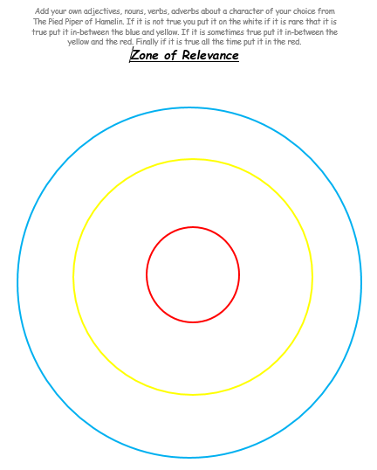 | Children will be able to justify responses with  evidence from the poem.
LO: Show key points of a poem using vocabulary from the text. | Pick a character from Monday’s poem and complete the character profile about them.  Challenge: find words and phrases from the text and copy them onto the sheet to support your ideas. | 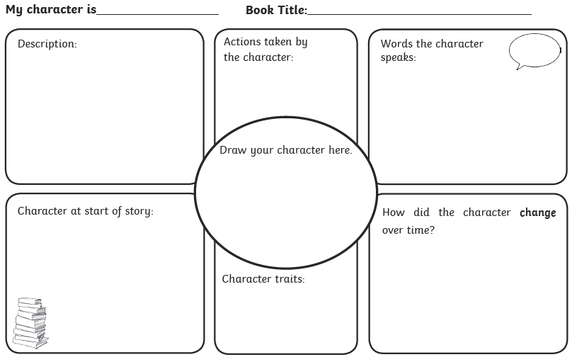 | Children will be able to represent key points in  a poem using images and key vocabulary.
LO: I can write a poem! | Write your own descriptive poem about either:  The Pied Piper of Hamelin  The Great Plague  An animal of your choice. |  | Children will be able to create a poem with  noun phrases.
LO: I can identify how poems should be presented. | You need to select a poem to perform in Friday’s Poetry Competition.  You can add actions, props or music for dramatic purposes. |  | Children will be able to identify how a poem is  presented.
LO: I know what a fronted adverbial is. | Watch this video and complete the quizzes. |  | Children will know how to identify a fronted adverbial.
LO: To know how to use fronted adverbials. | Identify fronted adverbials in sentences together. | Complete the learning booklet  answer the Qs in your book. | Know how to use a fronted adverbials.
LO: to use speech marks to punctuate direct speech. | Watch this video and complete the quizzes. |  | Children will use speech marks in writing.
LO: Recite poetry and present to others. | Recite a poem to others by heart. | Recite to the class. | Children will learn a poem off by hear and perform it to other.

Teacher: Phil Challoner Topic: The Plague
Text: Newspaper Articles. Genre: Recount: Newspapers
Intent | Implementation |  | Impact
Learning Objective | Teaching | Activity | Learning Outcomes
LO: identify that  information is presented via a news report. | Watch this  It’s a very old Sesame Street clip. | Answer these Qs in your book:  What is happening? How is this different to a story?  Have you seen anything like this before?  What does it remind you of? | Children will be able to identify that information is presented via a news report.
LO: Retrieve information from a newspaper report. | 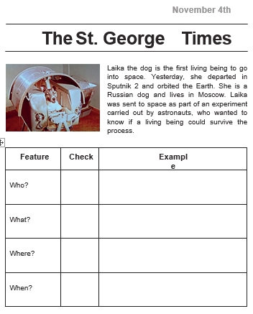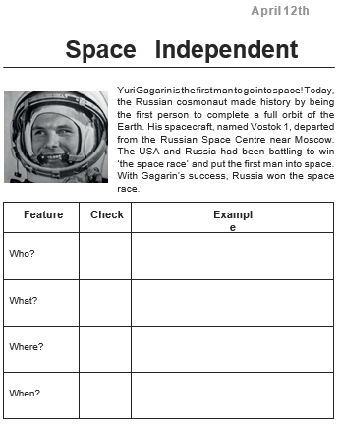 | See the two short news articles.  Can you think of some true and false questions you could ask about these articles? | Children will be able to read, discuss and  retrieve information from a newspaper text.  Children will be able to respond to, and generate true/false statements (Point + Evidence).
LO: What are the features of a newspaper? | Click here. | Recognise the features in the quiz on the website from the teaching session. | Children will be able to analyse the structure of a newspaper report.
LO: Identify the features of a newspaper | 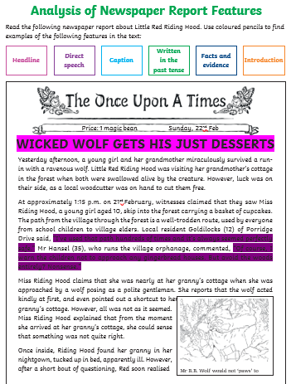 | Use a highlighter to find the features in the newspaper article. | Children will be able to explain how  paragraphs are organised in a newspaper report.
LO: identify the language used in newspapers. | 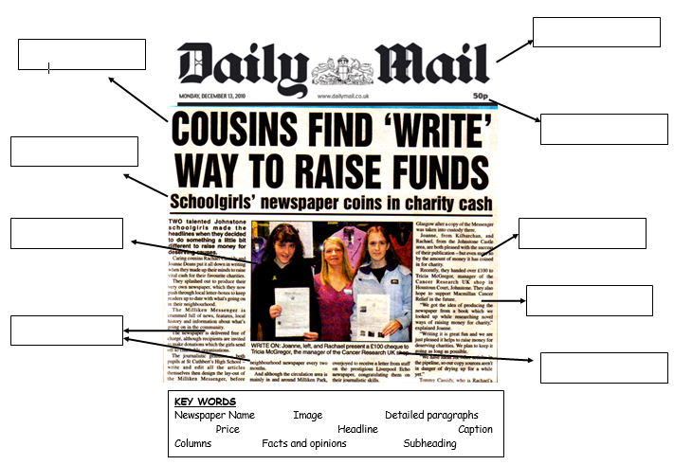 | Can you label the correct features?  Challenge:  Can you find any vocabulary that you think is unique to newspaper writing? Use a highlighter or pen to underline the words you find. | Children will be able to identify the language features of a newspaper report (recount).
LO: Create your own news report from Hamelin- speaking and listening. | Pick a story to report on:  -The Mayor is searching for someone to solve the rat infestation.  - The Pied Piper rids Hamelin of rats.  - The Pied Piper seeks revenge by taking all the children.  In your groups, make your own news report.  We’ll film them and watch them back together. |  | Children will be able to develop ideas using drama.
LO: Identify the language features of headlines. | See this link. | Create your own headline for your newspaper story. | Children will be able to investigate and decide on an appropriate headline.
LO: Plan our Hamelin newspaper report using the 5 Ws. | 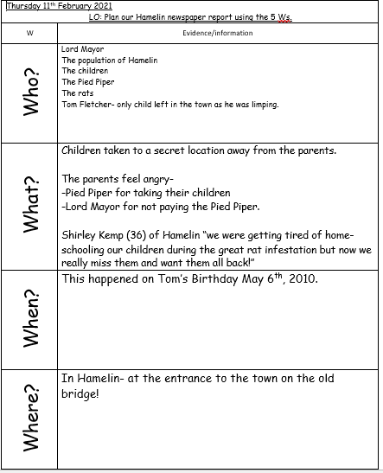 | Complete the 5Ws | Children will be able to create their own plan.
LO: To use your knowledge of the plot of the Pied Piper to plan your own newspaper article. | Discuss the order of the story and how this will influence the news report. Note ideas down on plan. | 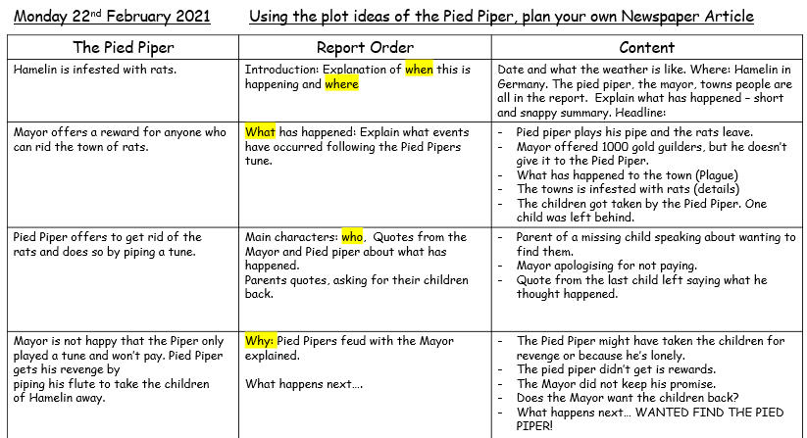
LO: To Write the Introduction to your Pied Piper Newspaper Article and come up with a snappy headline. | The introduction should include following:  - Where and when the event has happened.  - A snappy headline  - Information about the Plague.  - Capital letters for Proper Nouns. | Remember: stick to the main plot ideas of the original fairy tale.  Time for writing with checklist of ingredients. | Children will be able to write a newspaper  report with:  - appropriate pronouns  - noun phrases appropriate to non-fiction.
LO: Write the explanation report of your Newspaper article. | The explanation of events should include sentences with the following:  - A range of sentence lengths.  - Over the top language.  Past tense sentences | Remember: focus on key facts about what has happened in Hamelin. | Children will be able to write a newspaper report.
LO: Introduce the characters in the report. | This section of the article should include:  - First person accounts of the event.  - Details about the Name and age of the people.  - Correct use of speech marks. | Remember: include a first person account from two characters about their opinion of what has happened. | Children will be able to write a newspaper report.
LO: Write ‘why’ section of your article | The Why section and ending should include sentences that do the following:  - Use an alliteration to describe an event or person.  - Use of correct pronouns.  - A rhetorical question to finish. | Remember: Speculate about the Pied Pipers actions and decide how you want to end your article. | Children will be able to write a newspaper report.

