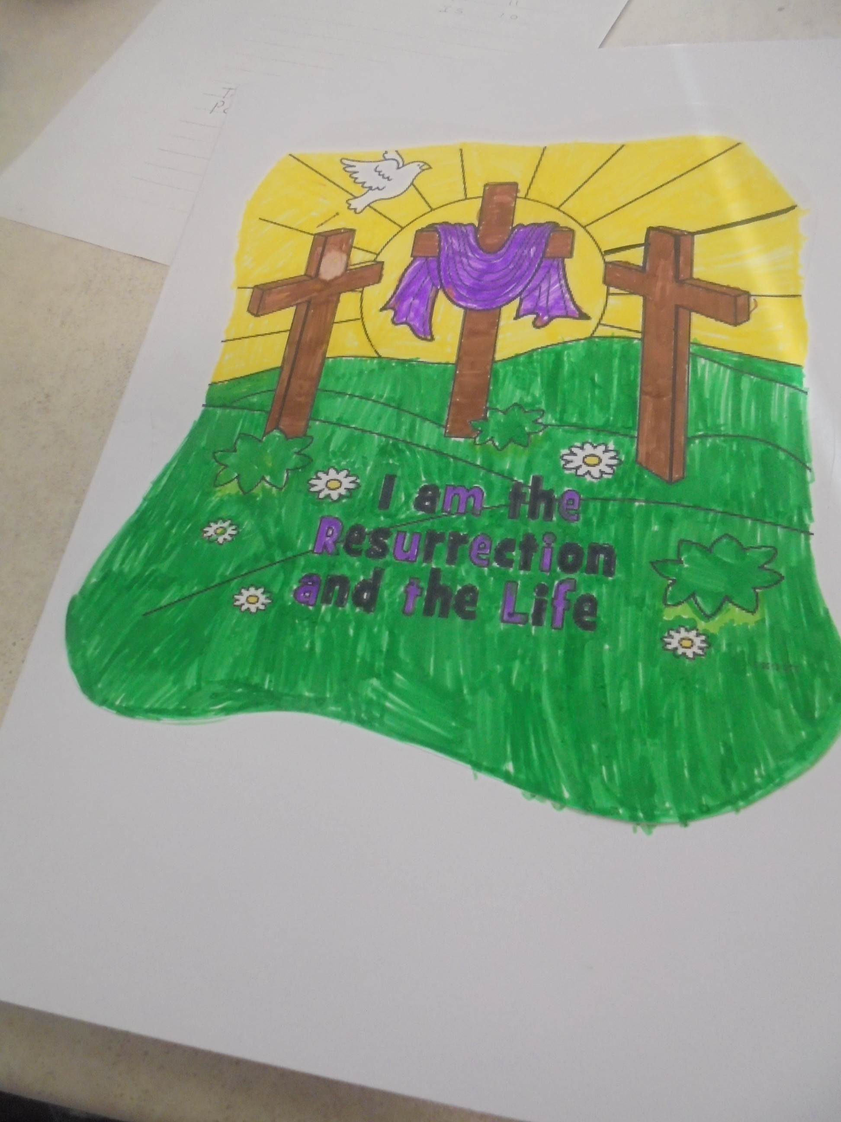

St. Joseph’s Chaplaincy News
Stations of the Cross

Members of the Chaplaincy team helped the R.E Coordinator to deliver the stations of the cross prayers every Tuesday in lent. The display with prayers is in the hall for all to see.
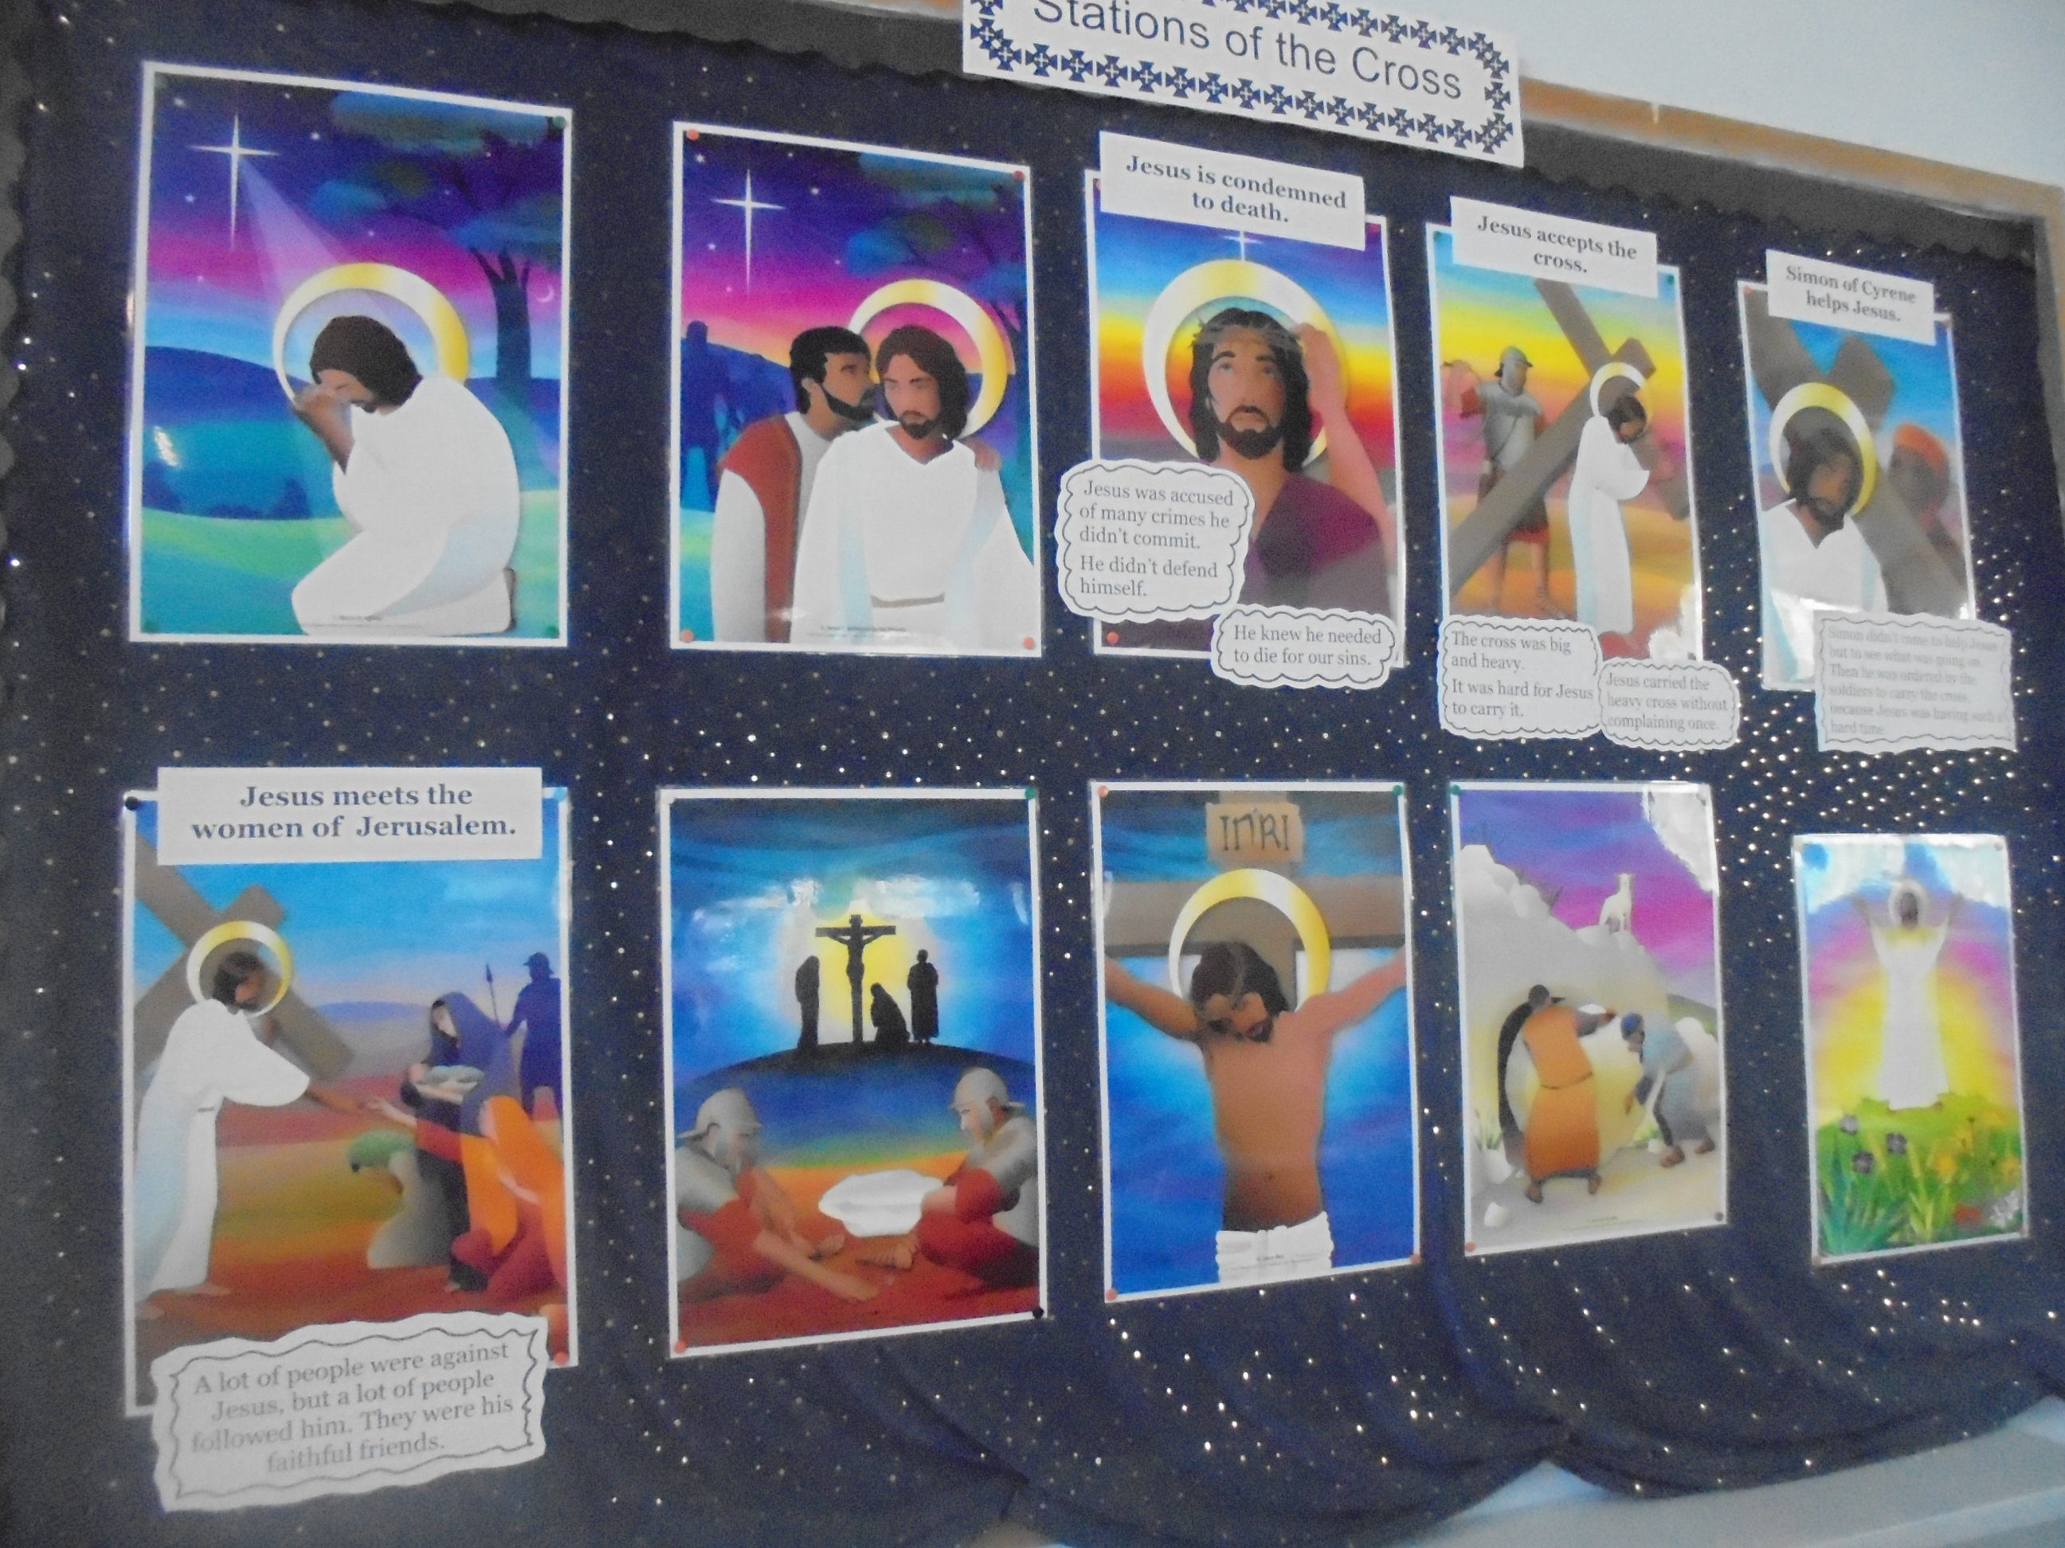
The Greatest Love story of all!

The “greatest love story of all” was told by the Chaplaincy team on Monday April 8th. The team created a short film clip detailing Holy week for the family liturgy.

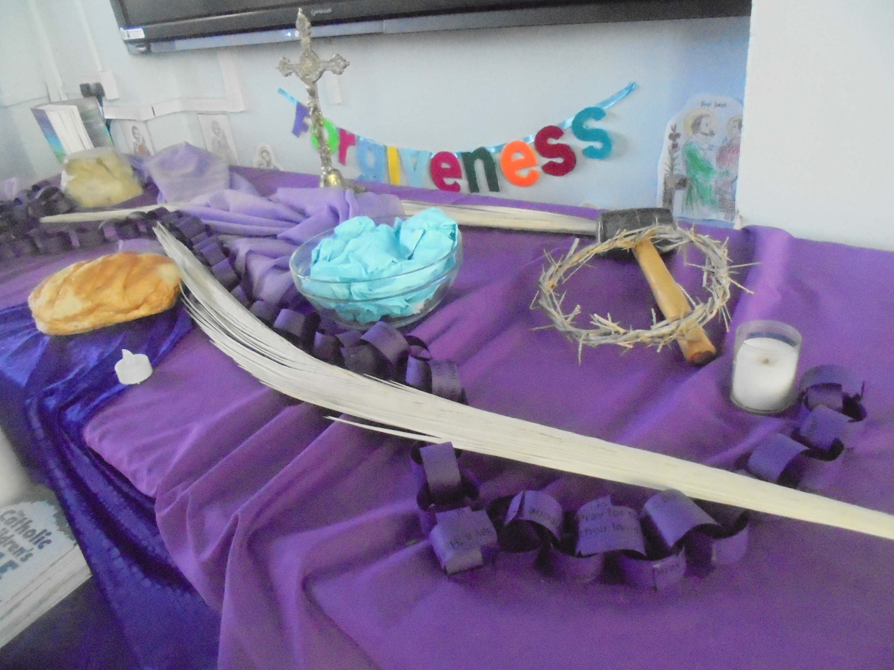
Prayer and quiet reflection time takes place in our chapel on Tuesday Mornings before school, starting at 8.30 and finishing at 8. 45.

The Chaplaincy Team’s motto and aim is to spread the “Good News” throughout the school and to grow with Jesus every day.
All the news from St. Joseph’s Catholic School Chaplaincy team.
The chaplaincy team delivered an Easter Card to Father John to thank him for visiting us every Wednesday.

